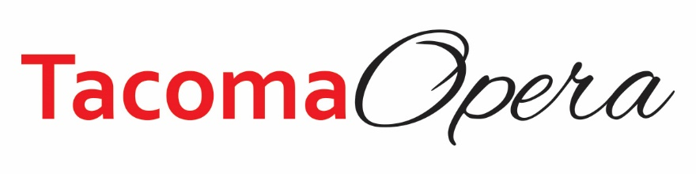

Virtual Silent Auction, November 29 – December 5, 2021
Streamed Program, Sunday, December5, 2021

Auction Item Donation Form

Donor/Business
Contact Person:
Address:
City: | State: | Zip:
Phone: | Email:

Donated Item Name:

Description:

(Please include all details such as quantity, size, color, number of persons, days/nights, expiration date and restrictions, if any.)

Estimated Retail Value of Donated Item(s) $
☐ Donor will provide actual item Delivery date:
☐ Item must be picked up from donor Pick up date:
(Please contact via email/phone below)

☐ Donor will provide a certificate
☐ Tacoma Opera please create certificate with the information provided
Donor Signature: | Date:
Donation Secured By:

DONORS: PLEASE MAKE A COPY OF THE COMPLETED FORM FOR YOUR RECORDS
Tacoma Opera | 47 St. Helens #201 | Tacoma, WA 98402 | 253-627-7789
Donation Deadline: November 14, 2021 | Return Forms to admin@tacomaopera.com
Tax ID: 91-1237511

